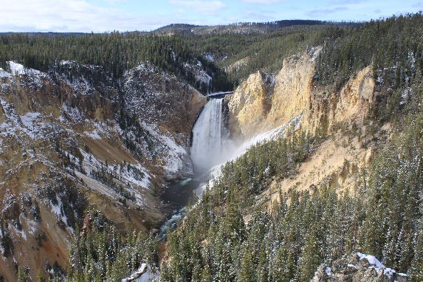
Signpost
Kateri Circles Vol. 6 Issue 4
April Signpost

St. Tekakwitha Opening prayer:

God of all nations and peoples. You have filled Your Creation with
Your mighty presence. Through Your handiwork You speak to our heard words that satisfy our every desire.
You called Your servant the Mohawk maiden Saint Kateri Tekakwitha to embrace the Gospel of your Son Jesus Christ to do Your will and to serve
others with the gifts You gave her.
May she who held tight to the cross of Your Son through her short life marred by sickness suffering and persecution, be our intercessor during our own trials. May her embrace of the Catholic faith and her openness to sharing Jesus with others inspire us
to be new evangelizers to all cultures and peoples.
Amen
Who do we need to bring in the circle?
Who do we need to pray for:
Family members who are sick. Family members who have died. Struggles that we are facing.
Let us bring our joys and sufferings into this circle.
Direction:
Spring
East
Yellow
Sin/ Apathy, Sloth
Fruits of the Holy Spirit/ Faith/ Goodness /Modesty
Gifts of the Holy Spirit/ Understanding/ Piety/

Topic:

Bartolomé de Las Casas
Bartolomé de Las Casas was born in 1474, Seville Spain. He is known as one of the strongest supporters of Indigenous rights during the early missionary period.
Although he is known throughout history as the defender of Indigenous, he did not start out that way. After he participated in the conquest of Cuba, he received a land grant that also included Native slaves. Being aware of their plight, he freed them, but realized that their treatment was a far worse problem than just on his land grant. In his preaching and actions he challenged not only his fellow land grant recipients, but the colonial government as well.
Realizing the atrocities that were going around him, he became greatly moved with justice for the Indigenous communities not just in Cuba, but in the rest of the Americas as well.
In 1515, he journeyed to Spain to plead his cause for the better treatment of the Indigenous. With others he formed a plan for their just treatment, “Plan para la reformación de las Indias.” And with the backing of the Royal Court returned to the Americas to implement the plan. Part of this plan was to develop “colonies of free Indians.” The first one was off the coast of present-day Venezuela.
He entered the Dominican Order and devoted more time in writing and debating the deplorable conditions of Indigenous and to continue his fierce opposition to Indigenous slavery. His famous works Historia apologética and the Historia de las Indias set the groundwork for the future tools that would be needed to work for justice for the Indigenous communities for centuries to come.

Church and Indian Country Podcast Questions:
- How does the early missionary period have an impact on your ministry?

- What are some misconceptions that people have about the early missionary period?

- How do we challenge those misconceptions?

- Why is Bartolomé de Las Casas important in understanding the early history of European conquest of the Americas?

- What was the results of Bartolomé de Las Casas’ writings and thoughts? What is significant about his writings concerning his impressions of Native peoples?

- What virtues does Las Casas have that could be a model for Native ministry.?

- How do I find out more about Las Casas?
- How do I get the word out about Las Casas to the parish, and/ or Tribal communities? For those who want more about Bartolomé de Las Casas could you recommend any resources that you think will be helpful?

Closing prayer:
From the Black and Indian Mission Office:
God of all nations and peoples. You have filled your creation with Your mighty presence. Through Your handiwork You speak to our hearts words that satisfy our every desire.
You called Your servant, the Mohawk maiden Saint Kateri Tekakwitha to
embrace the Gospel of your Son Jesus Christ, to do Your will and to serve others with the gifts You gave her.
May she who held tight to the cross of Your Son throughout her short life marked by sickness, suffering, and persecution, be our intercessor during our own trials. May her embrace of the Catholic faith and her openness to sharing Jesus
with others inspire us to be new evangelizers to all cultures and peoples. May she who sought our Jesus in the Blessed Sacrament lead up to similar reverences for
the Eucharist so that, like Saint Kateri, our last words may be, “Jesus, I love You.” Amen.

Notice:
Although this was composed by Rev. Michael Carson, the USCCB and the Subcommittee on Native Americans is not responsible for the content. You may use any or all of the “Signpost” for the benefit of the Tekakwitha's Circles. This is only a suggested guide. Use what you find useful. Each addition has been reviewed by the Tekakwitha Executive Board. If you have any feedback on how the “Signposts” can be improved, I would love to hear from you at mcarson@usccb.org The Tekakwitha Conference holds the copyright.
Rev. Mike Carson

